Length. The length of the papers (including title, abstract, keywords and summary), according to the section of the journal to which they are intended, should be as follows:
- Doctoral studies: minimum 25 and maximum 30 pages. These guidelines apply to studies that with such consideration are addressed to both the "Studies" section and the "Human Resources Studies" section.
- Case-law discourses: minimum 6 and maximum 8 pages.
- Discussion forum: maximum 7 pages.
- Case studies: maximum 20 pages.
- Bibliographical reviews: maximum 3 pages.
Structure. If the proposed contribution is a doctrinal study of both Labour and Social Security Law and Human Resources, it is recommended that the headings develop the following aspects:
INTRODUCTION
OBJECTIVES
METHOD
RESULTS
DISCUSSION
CONCLUSIONS
BIBLIOGRAPHIC REFERENCES
CURRICULUM
APPENDICES/ANNEXES
For papers addressed to the section "Case-law discourses", the structure will follow four sections:
- REGULATORY FRAMEWORK
- BRIEF SUMMARY OF THE FACTS OF THE CASE
- KEY JUDICIAL DOCTRINE
- SIGNIFICANCE OF THE ESTABLISHED DOCTRINE BEYOND THE CASE
In the case of papers addressed to the "Discussion forum" and "Case study" sections, the internal structure will be left to the author's discretion.
Form for in-text citation. Legislative or case-law references should contain all the necessary data for their adequate location and be neutral. Identifiers linked to unofficial databases with restricted access will not be accepted.
- Indirect or referential citation in normal text
When paraphrasing or alluding to ideas from another work, the author and the year of the work should be placed in parentheses. It is recommended to indicate the page if the text from which the quotation is taken is long (Author, Year, p. xxx). If the paragraph includes the surname(s) of the author, only the date of the reference should be written in parentheses (Year). If the author is not cited in the paragraph, then the surname(s) and the date should be written in parentheses (Author, Year). When the reference contains one or two authors, the surname(s) of both authors and the year should be written (Author and Author, Year). If the reference contains more than two authors, only the surname(s) of the first author should be used, followed by et al. (Author et al., Year).
- Direct or textual citation in normal text (less than 40 words)
The text of a citation of less than 40 words should be opened and closed with quotation marks. If the cited text reference has one or two authors, the surname(s) of both, the year and the page number(s) should be cited (Author and Author, Year, p. xxx –e. g.: Díez Mediavilla and Pérez López, 2021, p. 56 / Smith, 2020, p. 10–). When the reference has more than two authors, only the surname(s) of the first author should be written, followed by et al., the year and the page number(s) (Author et al., Year, p. xxx –e. g.: Díez Mediavilla et al., 2021, p. 56 / Smith et al., 2020, p. 10–).
- Direct or textual citation in normal text (more than 40 words)
If the citation is 40 words or longer, it should be written in a separate paragraph, without quotation marks and indented. At the end of the citation, the reference data should be included following these instructions: if the cited text has one or two authors, the surname(s) of both, the year and the page number(s) should be cited (Author and Author, Year, p. xxx). When there are more than two authors, only the surname(s) of the first author should be written, followed by et al., the year and page number(s) (Author et al., Year, p. xxx).
- Citations by number or type of authors
One: the surname(s) identifying the authorship and, in parentheses, the year and page(s) or the surname(s), year and page(s), all in parentheses.
In the case of citations of the same authorship with the same publication date, the year of publication will be suffixed to mark the difference [e. g.: (Díez Mediavilla, 2021a, p. 19) / Molina Navarrete (2019c, p. 5) / (Smith, 2022a, pp. 23-25)] and in the list of references they will be ordered alphabetically by title.
Two: the identifying surname(s) of both authors should be indicated and, in parentheses, the year and page(s), or the surname(s) of both, year and page(s), all in parentheses [e. g.: Rodríguez Márquez and Smith (2019, p. 8) / (Rodríguez Márquez and Smith, 2019, p. 8)].
Three or more: from the first citation, only the surname(s) of the first person appearing in the authorship list is given and et al. is added [e. g.: (Smith et al., 2020, p. 450].
In cases where this form of citation creates ambiguity because it mentions works that partially coincide in authorship and from the same year (e. g.: Molina Navarrete, Miñarro Yanini, Fernández Avilés and Lerouge, 2020, on the one hand, and Molina Navarrete, Miñarro Yanini, García Jiménez and Lerouge, 2020, on the other, which in both cases would be cited as Molina Navarrete et al., 2020), the necessary authors should be mentioned to clarify the reference (e. g.: Molina Navarrete, Miñarro Yanini, Fernández Avilés et al., 2020, in one case, and Molina Navarrete, Miñarro Yanini, García Jiménez et al., 2020, in the other).
Corporate or institutional authorship with acronyms or abbreviations: in the first citation the full name of the organization is listed and then the abbreviation can be used [e. g.: Organization for Economic Co-operation and Development (OECD, 2019) and then OECD (2019) / International Labour Organization (ILO, 2020) and then ILO (2020)].
Corporate or institutional author without acronyms or abbreviations [e. g.: Instituto Nacional (2018) / (Banco de España, 2020)].
Two or more papers in the same citation: if they correspond to the same authorship, they should be ordered chronologically, mentioning the surname(s) only once [e. g.: Molina Navarrete, 2019; 2020a; 2020b / Molina Navarrete (2019; 2020a; 2020b)]. If they are of different authorship, they should be ordered alphabetically, separated by semicolons [e. g.: Many studies confirm the results (Fernández Avilés, 2019; Miñarro Yanini, 2019; Molina Navarrete, 2020; Smith, 2018)].
Secondary source or citation within a citation (unless the secondary source is used as direct source elsewhere in the study, it is recommended not to include it in the bibliographical references): [e. g.: Molina Navarrete, 2015 (cited in Vallecillo Gámez, 2017)].
Undated source: "n. d." is placed in parentheses.
Anonymous source: the first words of the title of the cited work should be written [e. g.: (Management Report, 2013)].
Footnotes. These should be numbered consecutively and their text shall be included at the foot of the page, restricting them to the minimum necessary. Bibliographic references are not acceptable as footnotes.
Levels in the text. The numbering should be in Arabic numerals: 1.1. Second level title. 1.1.1. Third level title, and successives.
Schemes, drawings, graphs, tables. These should be numbered consecutively (using Arabic numerals) according to type (table, graph, etc.), and inserted in the appropriate place in the body of the article’s text. They shall have an explanatory footnote explaining what they contain and in which all abbreviations used must appear, so that they can be read and understood independently of the text. Likewise, the source from which they were taken must be expressly indicated; in the case of taking them from another author, express authorization must be obtained, and if the source or origin is the author himself/herself, "own elaboration" must be indicated. See example in section 3 of this document.
Article title
Article title in English
Name and two surnames of the first author (contact author)
Affiliation, City, Country
email@domain.com https://orcid.org/xxxxxxx
Name and two surnames of the second author
Affiliation, City, Country
email@domain.com https://orcid.org/xxxxxxx
Subsequent authors in the same way...
Abstract (compulsory)
Normal text... (no more than 20 lines).
Keywords: (compulsory, 7-9 words separated by semicolons, same characteristics as normal text).
Abstract in English (compulsory)
Normal text... (no more than 20 lines).
Keywords in English: (compulsory, 7-9 words separated by semicolons, same characteristics as normal text).
Summary (The exception to this requirement is the section "Case-law discourses". In the other sections, the summary and the internal structure of the text will correspond to the headings and subheadings into which the work is divided. Preferably, they should not include abbreviations and capital letters should not be used, except for those corresponding to orthography. These should be numbered using Arabic numerals and follow a graduated block layout, with a maximum of 3 levels. None of these should have a final period. There should be a blank line before and after each of these).
Note: if the article has funding, it goes here.
- Title of the heading (if it is a doctrinal study, an introductory heading is recommended; if it is a work directed to the "Case-law discourses" section, a summary of the applicable normative framework).
Text containing section.
- Title of the heading (if it is a doctrinal study, it is recommended to identify the goals of the research presented; if it is a work directed to the "Case-law discourses" section, it is recommended to include a summary of the facts of the case).
Text containing section.
- Title of the heading (if it is a doctrinal study, it is recommended to state the participants or sample, methods, techniques, procedures, approaches and models that were considered for obtaining the research results; if it is a work addressed to the "Case-law discourses" section, the key points of the judicial doctrine should be pointed out).
Text containing section.
Figure 1. Title of the figure
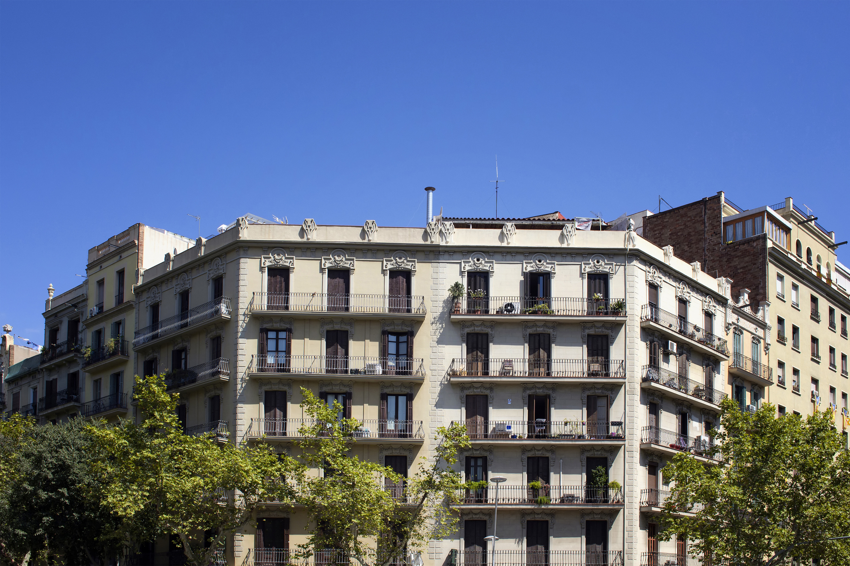
Source: text, text, text (compulsory).
Graph 1. Title of the graph
(The graph must be editable. It must be in image format, i. e., never send as PDF)
Source: text, text, text (compulsory).
Table 1. Title of the table
Header | Header | Header
Text in table | Text in table | Text in table
Source: text, text, text (compulsory).
- Title of the heading (if it is a doctrinal study, it is recommended to expose the results obtained; if it is a work directed to the "Case-law discourses" section, this will be the last heading and it will address the significance of the established doctrine beyond the case).
Text containing section.
- Title of the heading (in doctrinal studies, the results will be analysed, discussed and compared with similar existing research in the scientific community, and methodological aspects of the research presented that could be improved will be reflected upon).
Text containing section.
- Title of the heading (conclusions)
Text containing section.
- Bibliographical references
The American Psychological Association style (APA, latest edition) should be used for the organization and drafting of the bibliographic references. All references, regardless of their type (book, article, thesis, etc.) must be included in alphabetical order by surname, without exception. If two or more references are attributed to the same author, each of the mentions shall be articulated in a complete and independent manner, avoiding the use of hyphens. It is important to emphasize that the use of references will be evaluated by the reviewers on the following aspects:
  - The correct citation of the reference, according to the APA bibliographical style (latest edition).
  - The correspondence between the bibliographic references listed at the end and those mentioned in the citations in the body of the work.
  - There will not be a complementary bibliography section.
  - Self-citations should be restricted to essential cases.
  - Its length is limited to 3 pages.
Text containing section.

Curriculum
Name and complete surname(s) of the first author (contact author):
A summary of the author's curriculum vitae not exceeding 6 lines (single paragraph, plus information on the percentage of the specific contribution of each author to the work submitted for publication).
email@domain.com
https://orcid.org/xxxxxxx
Name and complete surname(s) of the second author:
A summary of the author's curriculum vitae not exceeding 6 lines (single paragraph, plus information on the percentage of the specific contribution of each author to the work submitted for publication).
email@domain.com
https://orcid.org/xxxxxxx
Subsequent authors in the same way...
- Appendices/Annexes (Times New Roman 12, bold, justified, single-spaced, with Arabic numerals).
Text containing section.

